**Site Plan**

The website's purpose is to make the Bountiful Foods company known to a wider public, displaying its healthy and fresh food options, including organic, make-to-order, and fruit drinks and fruit bags to the local population and tourists visiting the coastal areas.

**Target Audience**

The intended audience is health-conscious individuals who prioritize fresh, organic, and locally grown foods. These individuals are typically either located in the coastal region of Carlsbad’s coastal, California, or visiting the area. They look for convenient and accessible options for their food needs, whether it be through visiting the local store, utilizing their food trucks, or ordering online. The target audience includes both local residents as well as tourists visiting the coastal areas of Carlsbad, California.

**Personas**

First, Lisa is a 35-year-old resident of Carlsbad, California, she seeks convenient access to fresh produce and values supporting local business. She attends the Bountiful Foods storefront in Carlsbad and occasionally orders through their website for home delivery.

Second, Tony is a 28 years old tourist who loves exploring the coastal areas, seeking unique food experiences and local flavors. Tony relies on Bountiful food trucks during his travels and values their organic and locally sourced options.

**Typography**

Heading font: Kalam

Paragraph font: Sans Serif

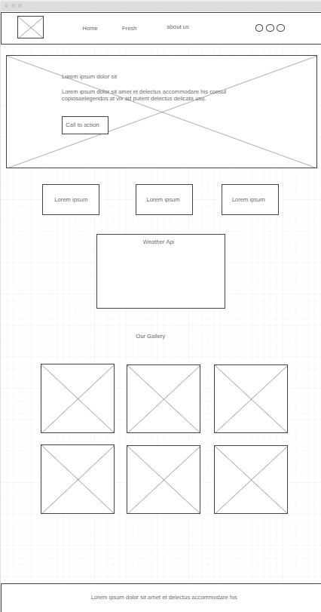

Large View

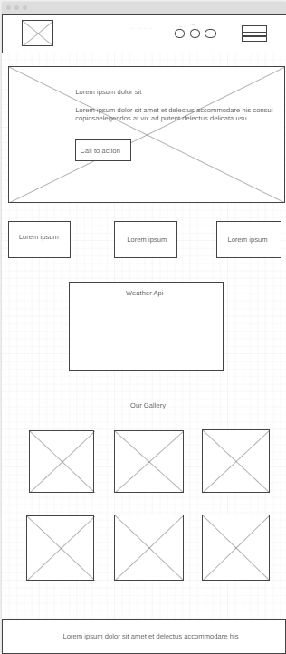 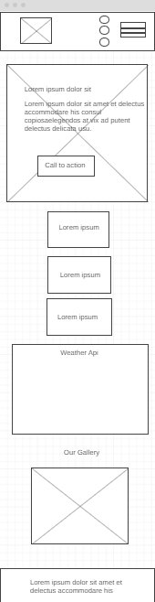

Small view

Medium view